Etiquette is not a four letter word
By Theresa A. Husarik

Like the saying goes, “Mean people suck” and that holds true for every aspect of life, including behavior on the slopes. The most basic rules are just common sense, but sometimes when we get excited about that new dumping of fresh powder, those brain cells holding the “common sense” information take a little vacation. So, to reel those brain cells back in, make this your mantra: “There are other people on the slopes” and everything else should fall in place.
But let’s elaborate. There are other people—of all abilities—on the slopes. There are some people that are a lot slower than you and some that are a lot faster than you. People with less experience and want to be cautious, and people who ski backwards in their sleep and just want to go for it. But, the mountain is big and has room for everyone as long as we are considerate.
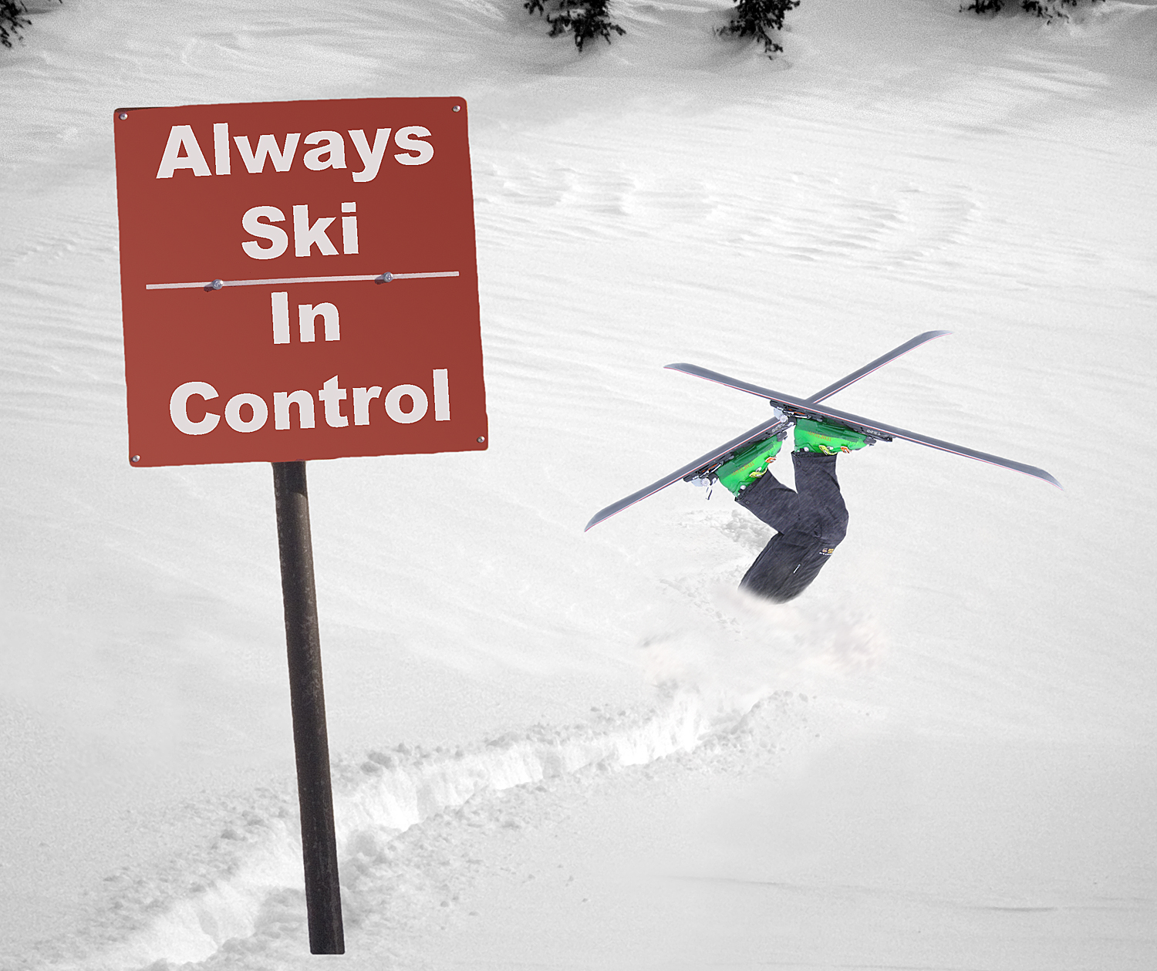
- Wait your turn in line and get in the right line. Signs such as “Ski Patrol Only” are there for a reason. Everybody wants to get to the top, same as you do. Nobody likes a line jumper.
- Ski in control. You will see signs all over the mountain reminding you of this. Obey them. It is not only courteous, but it is the law. In some cases, your pass could be revoked if you are found being too reckless.
- Watch what is happening with your poles and your skis! Isn’t it annoying to have someone in line behind you rolling over your brand new skis? And how about being poked by a carelessly flung pole? Other people don’t like it either. Pay attention.
- If you choose to ski on the beginner slopes (or even if you have no choice because that is what you get at the bottom of the run and near the lift) be courteous of the beginners who are there because that is the only place their skill level will allow them to go. Save the death-defying descents for the black runs.
- The skier in front of you (i.e. downhill of you) ALWAYS has the right of way. They can’t see you, but you can see them. It is your responsibility to avoid him or her.
- It is best to not pass too closely and instead, give the person in front of you a wider berth. Of course that is not always possible, such as on a cat track. So when you do need to pass someone fairly closely, call out "On your left" or "On your right”. But do it as a courtesy, not as an admonition that “I’m coming through so get out of the way.” For those who may be going slower on these tight places, please don’t use the whole track for your turns; try to keep to about 1/3 of one edge.
- Be cautious where trails merge and cross over only if it is clear. Just like walking into traffic on the road, look for oncoming traffic and yield if there is any. Don’t cut anybody off or you could find yourself and somebody else hurt.
- If there is an accident, and ESPECIALLY if you have caused it, stay with the injured person until help arrives. Alert someone to contact the Patrol.
- Don’t you hate wasting time waiting for your appointment to show up? Well other people hate it too. Don’t keep people waiting for you. Establish a time and place to meet and stick to it. If something comes up, use a cell phone or other means of contacting the other party.

- Skiing Specific Tips:
  - Be careful with your poles (don’t accidentally poke somebody because you are not paying attention, or talking with your hands while holding poles.) Watch what you are doing with your poles and your skis! There is nothing more angering than having someone barge in front of you, stand on your board (thus trapping you), and then scraping a pole all the way down your brand new ride.
  - Don’t ski over somebody else’s skis while waiting in line.

- When skiing in a group:
  - Since groups generally want to stay together, make sure everyone knows which lift and run is the next target.
  - If you come to a trail branch-off, make sure someone stands guard so those in the back of the pack know which branch to take.
  - Let the slowest skiers have time to rest up at each stop.
  - Have one of the better skiers bring up the rear in case the less-experienced ones need help.
  - Try to make sure no one in the group has to go up the chairlift by themselves.
  - If you decide to leave the group, make sure at least someone knows. It’s pretty annoying to be waiting for someone who is never going to show up.
  - If most of the rest of the skiers in the group are way better than you, don’t be a whiner. Either opt to break off on your own or try to keep up; ask the leader to slow down or take more rests.

The bottom line is Respect others' rights on the slopes, just as you expect them to respect yours. If you stick to that, everyone should have an equally great time.

